# PeopleSafe - Cumulative Refills at the Refill Drug Level / DEA Class Drugs

Edit PBO (Plan Benefit Override) screen

Related Documents

**Description:** Detailed Edit PBO screen information including the Cumulative Refill fields for DEA Class Drugs for the opted in clients.

|  |
| --- |
| Edit PBO (Plan Benefit Override) screen |

There is a requirement to allow DEA (Drug Enforcement Administration) class drugs to have different cumulative refill threshold than all other drugs.

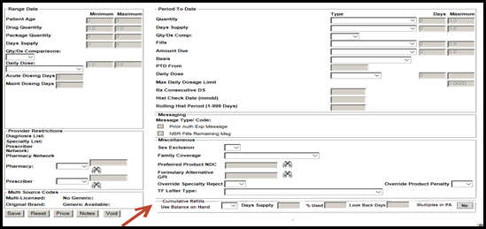

 **View only access**.

The following fields are in the Edit PBO screen.

|  |  |
| --- | --- |
| **Fields** | **Information** |
| Use Balance on Hand | Displays regardless of the value of the field. This field includes a drop down with the values of Blank or “B.” This defaults to blank. |
| Days’ Supply | Displays regardless of the value of the field. This field allows entering up to three digits (between 1 and 999). This defaults to blank. |
| % Used | Displays regardless of the value of the field. The % Used default value will be blank. It allows entering up to three digits (between 1 and 100). |
| Look Back Days | Displays regardless of the value of the field. It allows entering up to three digits (between 1 and 999). This defaults to blank. |
| Multiples in PA - RxClaim | Allows multiple cumulative refills on one PA (Prior Authorization). When this happens, the Multiples in PA flag is set to **true** and displays as **yes** in PeopleSafe.  The last updated cumulative refill displays in PeopleSafe.  The flag for Multiples in PA will be labeled “Multiples in PA”- RxClaim and will be editable based upon the representative’s security access.  **Note:** View or update one cumulative refill per PA in PeopleSafe. To view Multiple PA’s; access RxClaim.   * The Multiples in PA label displays regardless of the value of the field. This field will display “Yes” or “No,” with a default to “No.” * False will display as **No** on the screen. * True will display as **Yes** on the screen.   **Notes:**  New error messages for Cumulative Refill will display in a pop up.  Only selected users have the ability to Add or Edit the Cumulative Refill fields.  You can **view** Cumulative Refill fields. The Cumulative Refill labels will display, and Cumulative Refill fields will be disabled when the PA type is NDC< NDC List or MIC. |

Top of the Document

|  |
| --- |
| Related Documents |

[PeopleSafe - Plan Benefit Overrides (PBO) CCR (024671)](https://thesource.cvshealth.com/nuxeo/thesource/#!/view?docid=f075340f-87ec-41b3-bdeb-16422d0fed0e)

[Customer Care Abbreviations, Definitions, and Terms Index (017428)](https://thesource.cvshealth.com/nuxeo/thesource/#!/view?docid=c1f1028b-e42c-4b4f-a4cf-cc0b42c91606)

[Customer Care Abbreviations, Definitions and Terms - N (051687)](https://thesource.cvshealth.com/nuxeo/thesource/#!/view?docid=1992cb33-0790-40c8-9bb4-857aed48c8b4)

**Parent Document:** [CALL 0049 Customer Care Internal and External Call Handling](https://policy.corp.cvscaremark.com/pnp/faces/DocRenderer?documentId=CALL-0049)

Top of the Document

Not to be Reproduced or Disclosed to Others without Prior Written Approval

**ELECTRONIC DATA = OFFICIAL VERSION / PAPER COPY = INFORMATIONAL ONLY**